Software System Documentation

for

CipherChat

A Secure, Decentralized Chat Application

Version 1.0

Prepared By

|  |  |  |
| --- | --- | --- |
| Ottor Mills | ID#: 180917 | Email: 180917@gist.edu.cn |
| David Thomas | ID#: 180912 | Email: 180912@gist.edu.cn |
| Nicoy Smith | ID#: 180902 | Email: 180902@gist.edu.cn |
| Kenneth Anglin | ID#: 180907 | Email: 180907@gist.edu.cn |

|  |  |
| --- | --- |
| Course Instructor: | Thomas Canhao Xu |
| Course: | SWEN3010 |
| Date: | April 30, 2019 |

# Table of Contents

Overview 3

Server Side Implementation 5

Client Size Implementation 8

Classes 10

Future Implementations 11

Distribution of Tasks 13

# Overview

CipherChat is a decentralized and secure chat application that was created on the premise that everyone should be entitled to their privacy, especially while using the internet. It is free to use and open source which therefore means that the application’s source code can be peer-reviewed by users around the world and be deemed as secure; this is the main advantage of open source software. Using multiple cryptographic techniques, CipherChat creates a trustless network of interconnected nodes in which only the rightful recipient messages know the contents of the message by decrypting it. In other words the server’s in a CipherChat network primarily stores encrypted messages for clients.

Figure 1.0 shows the distinction between three popular network structures

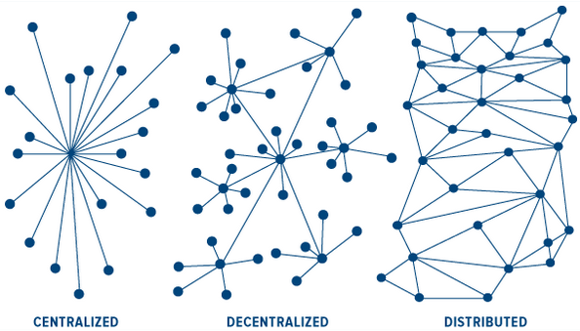

*Figure 1.0*

The CipherChat project makes use of a total of five languages. They are:

|  |  |
| --- | --- |
| Typescript | Used to create some server-side components which were transpiled into JavaScript |
| JavaScript | Main language used to create the server using the Express framework. It is also used as a supplementary language of the mobile application by implementing features not provided by Dart. |
| Dart | Main language used to create the mobile application using the Flutter framework. Flutter allows user interfaces and functionalities to be created using well defined classes / objects instead of using XML |
| SQL | The server uses the MYSQL database where as the mobile application uses an SQLite database. Both these databases require SQL in order to be interfaced |
| Bash | Used to create the operating scripts of the server, in addition to providing additional functionalities of the server such as SSL certificate generation |

# Server Side Implementation

The CipherChat server was written using the Express framework. By The Express framework it excels at handling repetitive, high-traffic but low intensity tasks, making it ideal for chat applications. Incoming requests are immediately handled as a background task (on the same thread) while the server continues to listening for more incoming requests. The CipherChat server utilizes load balancing which is provided by in loadBalancer.js file. Using load balancing incoming requests are immediately sent to one of many server instances running on separate threads.

These requests are subsequently pushed as a background tasked and handled (as mentioned earlier), maximizing efficiency. More servers may be added to a single machine (vertical scaling) and more machines may be added with more server processes running (horizontal scaling). The IP address of additional machines would be added to the “remoteServersUrls” array in the server’s config.json file.

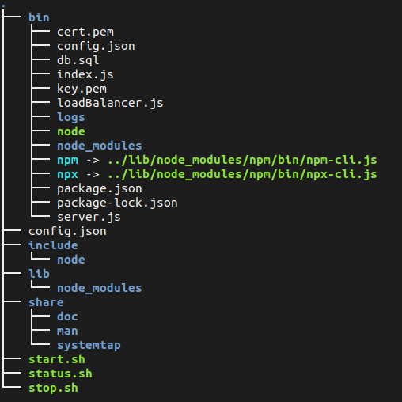Figure2.0 CipherChat’s Server File Tree (only salient files are shown)

*Figure 2.0*

Figure 2.1 CipherChat’s Server’s configuration file

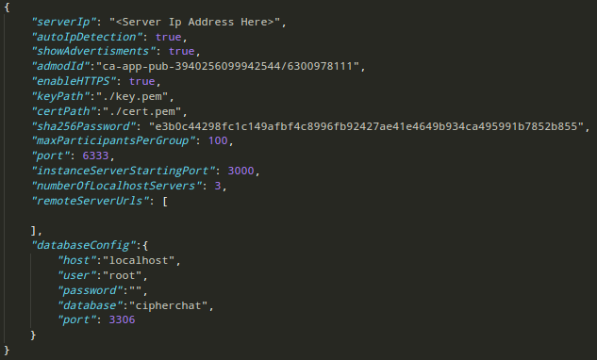

*Figure 2.1*

The config.json file acts as an interface for making quick changes to the server. Below is a description of each field:

|  |  |
| --- | --- |
| serverIp | The public IP address of the server can be manually set using this field. |
| autoIpDetection | A Boolean value which determines if the server should automatically get the public ip address of the server using and online API |
| showAdvertisments | A Boolean value which determines if the app should display ads. Ads on the chat screen. (Currently not supported by the app) |
| admodId | The desired admod ID from which to serve ads |
| keyPath | The path to the SSL private key used by the server in HTTPS |
| certPath | The path to the certificate file that is to be distributed among connected peers for HTTPS |
| sha256Password | The hashed password required by clients to create a new groupd on the server |
| maxParticipantsPerGroup | The maximum number of participants allowed to join a group |
| port | The port number of the server which is available to the public |
| instanceServerStartingPort | The starting port number of each load balanced server instance. The following port number are incremented |
| numberOfLocalhostServers | The number of load balanced server instances |
| remoteServerUrls | An array containing the private IP addresses of any server instances that reside on other machines |
| databaseConfig | A JSON object containing the configurations of the mysql database to be used |
| databaseConfig.host | The IP address of the mysql database |
| databaseConfig.user | The username of the database |
| databaseConfig.password | The password for the username of the database |
| databaseConfig.database | The name of the database to use |
| databaseConfig.port | The port number of the mysql database (default: 3306) |

# Client Size Implementation

Figure 2.2 CipherChat’s Mobile Application File Tree

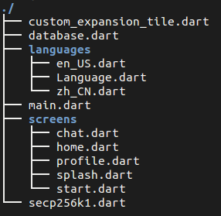

*Figure 2.2*

The diagram above illustrates the files that were created inside the lib folder of Flutter’s default project tree. The following files were used by the project:

* main.dart
* chat.dart
* home.dart
* start.dart
* database.dart
* secp256k1.dart

The main.dart file contains variables, functions and classes that are globally accessible to other dart files of the project. It also defines the screen routes of the application. The chat.dart file contains the layout of the chat screen from which messages is send and received, in addition to containing functions that aid connecting to the server. The home.dart file contains the layout of the home or index screen. It contains a list of all past conversations. The start.dart file contains the layout for joining or creating a new chat. The database.dart file container the Database class which contains all the necessary methods used to communicate with the the local sqlite database. The secp256k1.dart file contains the methods used in elliptic curve cryptography such as primary key generation and message signing. All other dart files that have not been listed are not yet implemented.

# Classes

Below is a listing of all the salient classes and description used in the CipherChat chat application

|  |  |
| --- | --- |
| Home | The Home class contains the layout of the Home or index screen of the cipher chat application. |
| Language | The Language class contains a reference to language files on the |
| DatabaseManager | Contains the methods that enable between the application and the SQLite database |
| Profile | The Profile class is responsible for displaying the profile screen and loading all the information related to the user |
| Chat | The Chat class is responsible for loading the chat screen. It contains methods used for sending messages as well as a polling method that receives messages in real-time |
| Start | The Class responsible for loading the connect-to screen. It provides the user fields to enter the ip address and port of the server that they would like to connect to, as well as a join option to join an existing chat by providing a valid joinKey |
| Secp256k1 | This Class contains all the methods necessary for encryption, decryption and signing of messages through the use of a private and composite keys |

# Future Implementations

Each of the following features may be implemented in future releases of CipherChat:

1. **WebSockets**

CipherChat is currently uses short polling to retrieve new messages. Although each request only required a few bytes, the total amount of data sent adds up over time, using bandwidth unnecessarily.

1. **Restricted Key Exchange**

Keys are currently exchanged through the use of a server, however this opens up the possibility of Man-In-the-Middle. In a future release of CipherChat public key exchange will only be allowed to through the use of QR Codes.

1. **Additional Hosting Incentives**

Additional incentives will be implemented in order to encourage more CipherChat servers to come online.

1. **Notifications**

Notifications will be implemented to notify the user of the arrival of new messages which is conventional among modern messaging applications

1. **Multilingual**

CipherChat is currently available in English only however it will support multiple languages overtime

1. **Sending of Files**

CipherChat will support multiple file formats in future releases.

1. **Broadcasts**

In a future release CipherChat servers will connect to other nodes and broadcast and receive messages. This will allow users to receive and send messages regardless of which server they connect to.

1. **DDOS Protection**

Distributed Denial of Service Attacks costs corporations millions of dollars annually. Since anyone can make requests to servers for free, a server immune to DDOS attacks is next to impossible; although certain measures may be taken to maximize the safety of a web service. The CipherChat network, as it is intended to be, is vulnerable to DDOS attacks. Securing a decentralized network from DDOS attacks is a daunting challenge. Research will be done as to how to secure the CipherChat network, one possible solution is through the implementation of a blockchain.

# Distribution of Tasks

|  |  |
| --- | --- |
| ID | Contribution (%) |
| 180917 | 30 |
| 180912 | 23.3 |
| 180902 | 23.3 |
| 180907 | 23.3 |